%PART A

F = [0.3 0.32];

A = [1 0];

DEV = [0.05 0.01];

[N, Fo, Ao, W] = firpmord(F, A, DEV);

%order is N = 146, but this didn't work in part C. Increase by 2

B = firpm(N+2, Fo, Ao, W);

%filter coefficients are in B

%PART B

nn = 1:length(B);

stem(nn-1, B(nn), 'filled')

xlabel('Time Index (n)')

title('Impulse Response')

%PART C

figure

ww = -pi:(pi/100):pi;

H = freqz(B, 1, ww);

plot(ww, abs(H)), grid on %entire plot

xlabel('Normalized Radian Frequency')

title('Magnitude of Frequency Response')

figure

subplot(211)

plot(ww, abs(H)), grid on %to zoom on passband

title('Passband Zoom')

subplot(212)

plot(ww, abs(H)), grid on %to zoom on stopband

title('Stopband Zoom')

xlabel('Normalized Radian Frequency')

%PART E

figure

plot(ww, angle(H)), grid on

xlabel('Normalized Radian Frequency')

title('Phase of Frequency Response')

Part B – impulse response

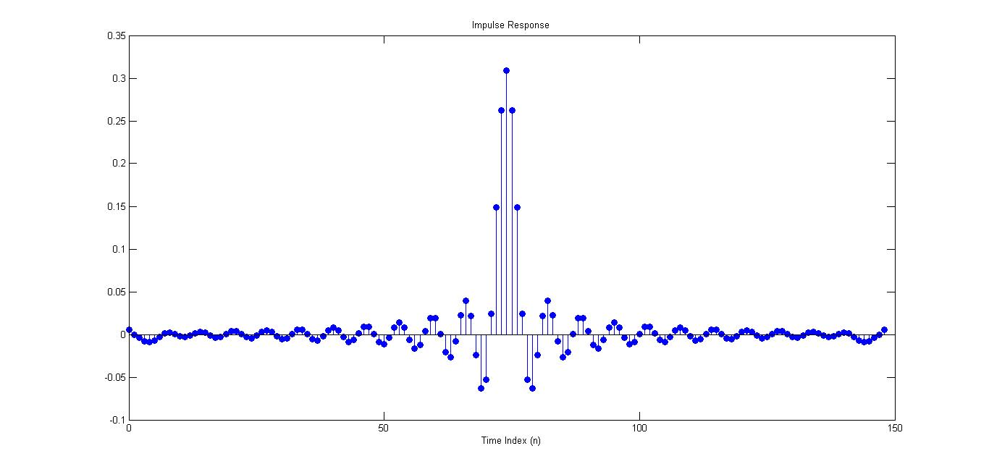

Part C – magnitude of frequency response

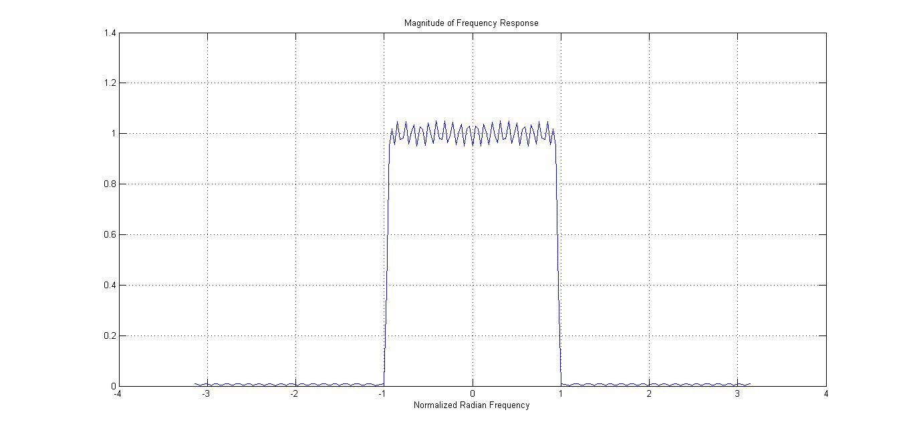

Part C – checking the passband and stopband

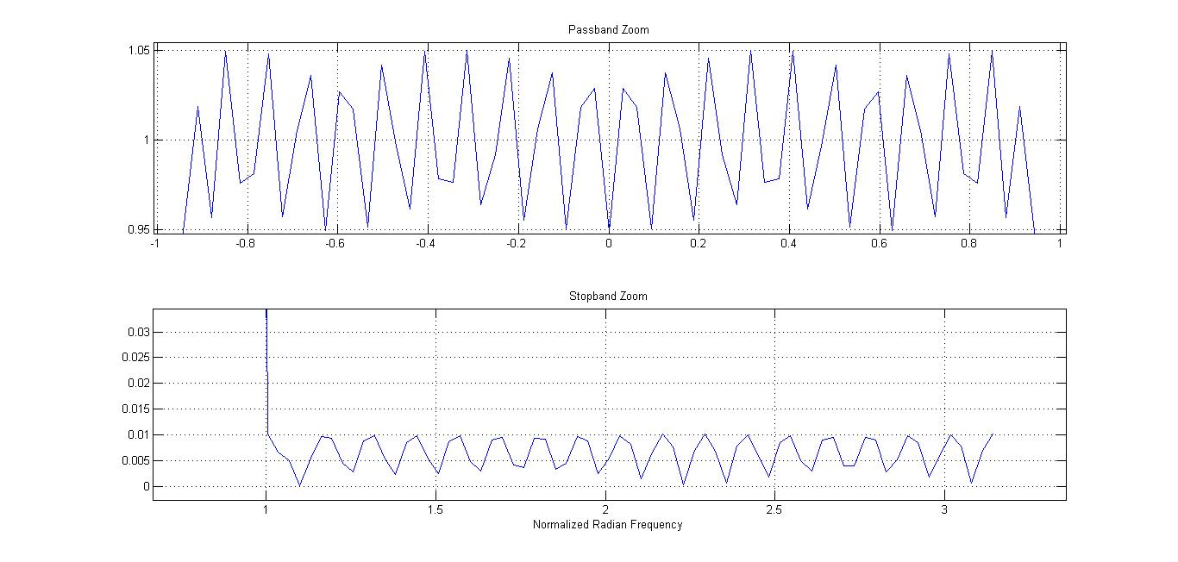

I had to increase order by 2 for the passband to stay between 0.95 and 1.05 and the stopband under 0.01.

Part D – phase of frequency response

